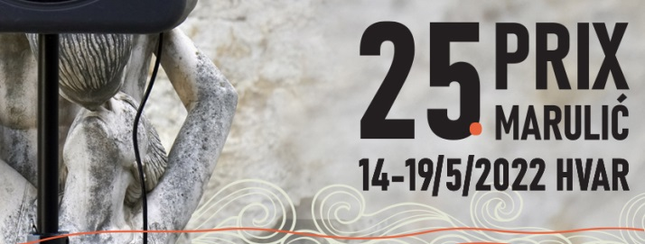

Registration Form
25th PRIX MARULIĆ, Hvar – Croatia, 14th – 19th May, 2022

Please return this form to PrixMarulic@hrt.hr before February 10, 2022

- ENTRANT

Production company
(name for freelancers)
COUNTRY you are representing

2. SUBMITTING PROGRAM

Original title
Title in English
Author(s)
Producer (s)
Director
Sound engineer(s)
Other key staff
Original language
Length
Date of 1st broadcast
I agree to having the program available online on the Prix Marulić website for 30 days and guarantee that all of the related rights are cleared

3. COMPETING CATEGORY (please mark)

Drama
Documentary
Short Forms

4. PERSON IN CHARGE AND MAIN CONTACT FOR ALL COMMUNICATION

Name and title
Email
Phone/mobile phone

The deadline for sending accreditation forms is April 11, 2022

(We will inform you about the pre-selection results by March 11, 2022)

We are also asking you to submit the synopsis of your programs as an additional document, along with the summary for the purpose of pre-selection. The synopsis gives the pre-selection jury a better foundation and idea of your program, thus helping greatly in the decision process. If your program is already translated to English, you may send us your script. In this case, you do not need to send us a synopsis! Also, if the program’s original language is English, you do not need to send us a synopsis!
It is important that your synopsis is detailed and precise enough (approx. 3 pages for Dramas and Documentaries and 1 page for Short Forms) to help our pre-selection committee understand that your program meets the requirements of the Prix Marulic Radio Festival.

5. SUMMARY IN ENGLISH (max 1500 characters with spaces):

